**Class Time-Table Generator**

**By**

**SAIYAM SHAH**

**17BIT104**

**KARAN SHETH**

**17BIT105**



**DEPARTMENT OF INFORMATION TECHNOLOGY**

**Ahmedabad 382481**

**Class Time-Table Generator**

**Mini - Project**

Submitted in fulfillment of the requirements

For the degree of

**Bachelor of Technology in Information Technology**

By

**SAIYAM SHAH**

**17BIT104**

**KARAN SHETH**

**17BIT105**

Guided By

**Prof. Pimal Khanpara**

**DEPARTMENT OF COMPUTER ENGINEERING**



**DEPARTMENT OF INFORMATION TECHNOLOGY**

**Ahmedabad 382481**

CERTIFICATE

This is to certify that the Seminar entitled “**CLASS TIME TABLE GENRATOR**” submitted by SAIYAM SHAH (17BIT104) and KARAN SHETH(17BIT105), towards the partial fulfillment of the requirements for the degree of Bachelor of Technology inComputer Engineering of Nirma University is the record of work carried out by him/her under my supervision and guidance. In my opinion, the submitted work has reached a level required for being accepted for examination.

Prof. Pimal Khanpara Dr. Sanjay Garg

Assistant Professor Professor and Head of Department

Department of Computer Engineering, Department of Computer Engineering,

Institute of Technology, Institute of Technology,

Nirma University, Nirma University

Ahmedabad Ahmedabad

**ACKNOWLEDGEMENT**

We would like to express my deepest appreciation to all those who provided me the possibility to complete this report. We acknowledge with thanks, the support rendered by Prof. Pimal Khanpara, under whose aegis we were able to complete the task in a given period of time. We also appreciate the constructive suggestions given by my friends to further enhance content of the report.

At the home front, we are extremely grateful to our family members for the support and encouragement, we got from them in successfully completing the report.

**ABSTRACT/ Outline**

In our project we have made time table generator where by taking basic information about every faculties in the institute like their name which courses do their teach and free time slot of all days in week we have generated timetable which will show the class timetable of four branches (i.e. CE, IT, ME, EC) showing course name and faculty assigned at each and every particular time from 9:00 a.m. to 6:00 p.m..

CONTENT

Certificate I

Acknowledgement II

Abstract III

Table of Contents IV

List of figures

Fig 5.1 Class Diagram of Project  11

Fig 5.2 Use Case Diagram of Project 13

Fig 7.1 Main page of time table generator 16

Fig 7.2 Lecturer data entries 17

Fig 7.3 the table-view format for lecturer data entries 17

Fig 7.4 Course Allocation 18

Fig 7.5 Final Time Table Generated Window 19

**1 Introduction 8**

1.1 Purpose 8

1.2 Product Scope 8

**2 Operating environment 8**

2.1 Operating System 8

2.2 Software Requirements 8

2.3 Hardware Requirements 8

**3 Functional Requirements & Interfaces**  **9** 3.1 Functional Requirements 9 3.1.1 Time-Table Window 9

3.1.2 Lecturer Window 9

3.1.3 View Time Table 9

3.2 Software Interfaces 9

3.3 Communication Interfaces 9

**4 Non-Functional Interfaces 10**

4.1 Performance Requirements 10

4.2 Security Requirement 10

* 1. Software Quality Attributes 10

**5 Preliminary Design 11**

* 1. Class Diagram 11
  2. Use Case Diagram 12

**6 Implementation 12**

6.1 Database Creation 12

## 6.2 Basic Data Classes 13

## 6.3 Database Connectivity Using JDBC 14

## 6.4 GUI Programming using JavaFX14

**7 GUI Windows 15**

7.1 Time-Table Window 15

7.2 Lecturer Window 15

7.3 Course Allocation Window 17

7.4 Final Time-Table Generated Window 18

**8 Summary and Conclusion 19**

8.1 Summary 19

8.2 Conclusion 19

**References 20**

**Appendix A – List of Useful Websites 21**

# 

# 1 Introduction

## **1.1 Purpose**

This document reports the functional and non-functional requirements of our project ‘Automatic Time-Table Generator’. It gives a description of the software’s scope as well as its requirements and constraints. Subsequently, it showcases the various modules designed using Java, JDBC and JavaFX.

## 

## **1.2 Product Scope**

This software is to be used as tool to view timetable of four departments(i.e. IT, CE,EC,ME). Here we have to enter the faculty details with their free time slot to take attendance and course which he/she going to teach. After that by taking details of all the faculties it will automatically generate the class timetable of each department. It will ease the whole method of generation of timetable manually by making generation process automatically.

**2 Operating Environment**

2.1 Operating System

• Windows 7 or Higher

2.2 Software Requirements

• Java 8 or higher

• Local MySQL Server

2.3 Hardware Requirements

• RAM: 200 MB

• Disk space:

• 124 MB for JRE;

• 2 MB for Java Update;

• 500MB for the Product;

• 500MB for database.

• Processor: Minimum Pentium 2 266 MHz processor.

• Browsers: Internet Explorer 9 and above, Firefox, Chrome

# 3 Functional Requirements and Interfaces

## **3.1 Functional Requirements**

The Functional requirements outline the minimum tasks the product will be capable of performing. Later version may see additional requirements added as the responsibilities of the product are further refined.

### 3.1.1Time-Table Window

On the main page it would show two buttons of which one is for data entry about the faculty and their information as written on above topic and other button is to see their time table.

### 3.1.2Lecturer Window

When the lecturer button will be clicked admin will have to add details of the lecturer like name & department and then by adding it will open new window which will ask for course that particular faculty is going to teach and his/her free time-slot.

### 3.1.3 View Time Table

The User will click on view time table button then the new window will show four buttons to choose which department time-table he/she wants to see. For example if user clicks on Information Technology button it will show full class time-table of IT Department.

## **3.2 Software Interfaces**

* Java Runtime Environment: Product will run on JRE and the Java Virtual Machine.
* Local MySQL Server: The database will interact with the product by responding to queries from the product using SQL.

## **3.3 Communication Interfaces**

The product will initially run locally, and the database will be stored on the client machine for the initial version. Later versions may see the database on a remote server and accessed using the HTTP protocol.

# 4 Non-Functional Requirements

## 

## **4.1 Performance Requirements**

Startup of the software must be fast and data retrieval should not take more than a few seconds. Multithreading may be used to streamlined performance. One thread handles GUI, another takes care of data reads and writes and another thread may be used for handling errors and exceptions.

## 

## **4.2 Security Requirement**

Care needs to be taken to prevent unauthorized changes in lecturer details by malicious entities in the database. This may be done by using an additional layer of user authentication, perhaps using an id and password.

## 

## **4.3 Software Quality Attributes**

The product will need to be visually appealing and must include an intuitive, easy-to-use design. The user must understand every aspect of the product by just looking at the relevant UI elements.

# 5 Preliminary Design

The preliminary design phase of the project involved creating the following UML diagrams using the open-source UML modeling software UMLet.

## 

## **5.1 Class Diagram**

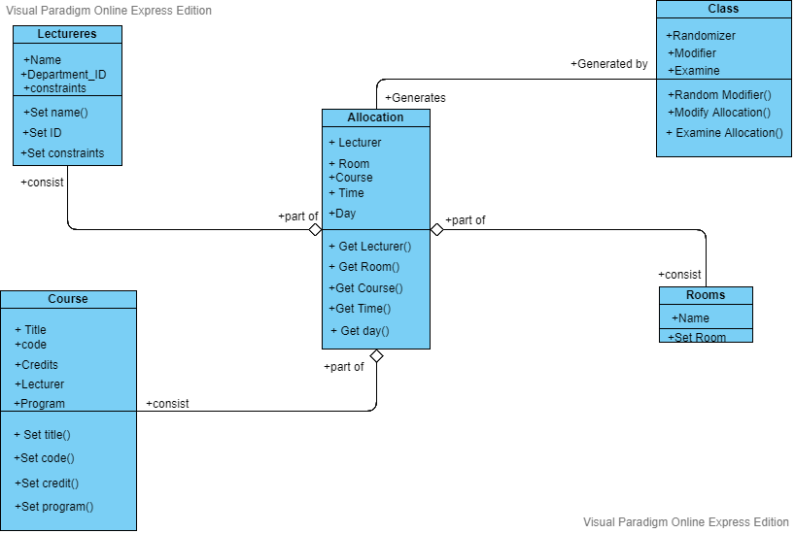

*Fig 5.1 Class Diagram Of Project*

**5.2 Use Case Diagram**

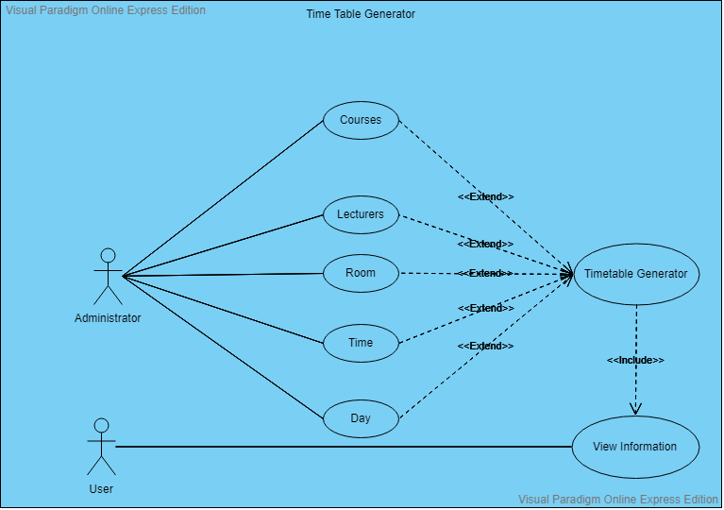

*Fig 5.2 Use Case Diagram of Project*

# 6 Implementation

## **6.1 Database Creation**

MySQL has been used for data storage. However, the admin can choose any other database management system of his/her choice. We have made two databases in which data of first database is retrieved and used in making of second database. The database includes the following tables:

1. First Name: It will have First name of the Faculty
2. Last Name:It will have Last name of the Faculty
3. Department: It will include information about which department that lecturer is teaching.
4. Courses:It will include all the subjects the given faculty will be teaching in the selected department. This is the reason why we require two databases as we need department for the selection of the courses.
5. Monday: It will include all free slots on Monday of the selected faculty.
6. Tuesday: It will include all free slots on Tuesday of the selected faculty.
7. Wednesday: It will include all free slots on Wednesday of the selected faculty.
8. Thursday: It will include all free slots on Thursday of the selected faculty.
9. Friday: It will include all free slots on Friday of the selected faculty.

## **6.2 Basic Data Classes**

1. lecinfo: This class basically consist of getter – setter method of teacher first name. lastname, department, and their id.
2. add_list_info: Basically it will fetch the information of courses as well as the free slot of whole week and will put the data to database.
3. choice_department: It will provide the different courses with respect to the branch means help you to select the course of whichever branch you want to select.
4. Pair: it will used to fetch the whole data and will store it into 3 dimensional array.
5. Allocation: It will help to allocate the courses with respective Lecturer.

## **6.3** **Database Connectivity using JDBC**

In order to connect the database to the application, Java provides Java Database Connection Drivers. The package java.sql has been imported in order to access the classes present in it for connecting the database. The class used for connection has been named as DatabaseConnection wherein an object of Statement interface “stmt” and an object of Connection interface “con” have been made. First, the class associated with the URL is retrieved using the forname(String URL) method of the class ‘Class’.Thereafter, the method getConnection(String URL, String root, String password)of class DriverManager has been called which, on establishing connection, returns it to con. A statement is created by the createStatement() method called by con and the resultant statement object is return to stmt. Two methods, getCon() and getStmt() are created which return con and stmt respectively. The method queryDatabase() is used for executing the queries which returns a ResultSet object while updateDatabase(), as the name suggests, updates the database.

## **6.4 GUI Programming using JavaFX**

In order to create GUI applications with less programming and more visual effects, JavaFX has been used. SceneBuilder has been used to enable the drag and drop facility for components of JavaFX. It then tells the corresponding JavaFX program to use the FXML file to display the user interface. The main class, HandyManager class controls the setting up and closing of all the stages for the given windows. The controller classes associated with them control the activities and functionalities of the windows.

# 7 GUI Windows

### 7.1 Time-Table Window

* Controller Class – Main

This Time Table Window consist of exactly two buttons and a label “welcome to the time table generator”. There are of Allocation button and other one is of lecturer button. The lecturer button functionality is to select the lecturer any either of four branch and allocate each lecturer to his subject respectively and for this add_submit_info() method will be called, While the other button Allocate functionality is to generate the time table of four branches for this add_submit1_info() method will be call.

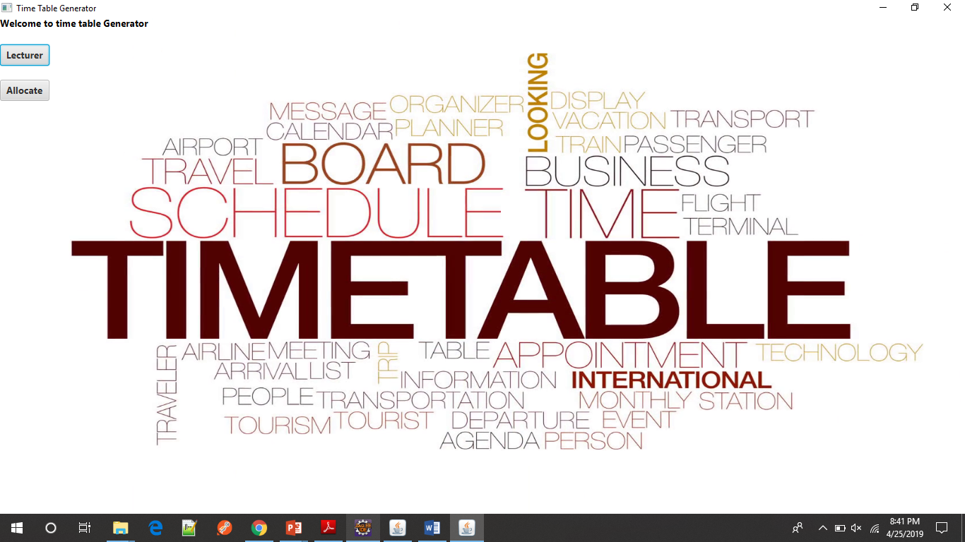

*Fig 7.1 Main page of time table generator*

**7.2 Lecturer Window**

* Controller class – lecinfo

This lecturer window will be open when the lecturer button is been clicked by the user on that main page. This window will open in an table view layout consist of four columns firstname, lastname, department, lecturerId. Also there are two textview the first one for lecturer first name and other for the lastname and one choice list to select the particular department. There also consist of three button “ADD” button, “DELETE” button and the third “Go to Main time table page”

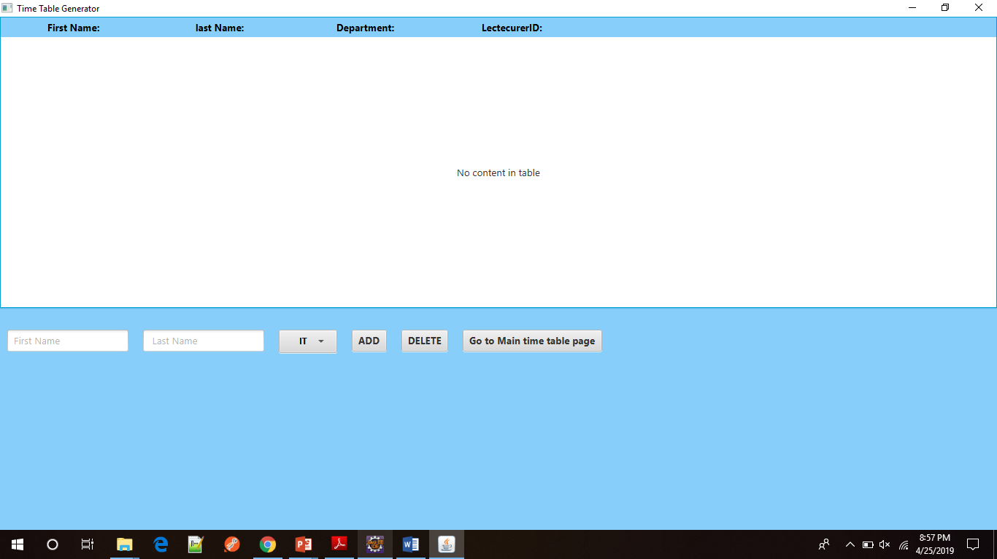

*Fig 7.2 Lecturer data entries*

whenever you click the add button the first name, lastname and the department you choose in the choice list is automatically added in that table also the lecturerId is automatic generated by itself and is displayed over the window as shown in figure 7.3.

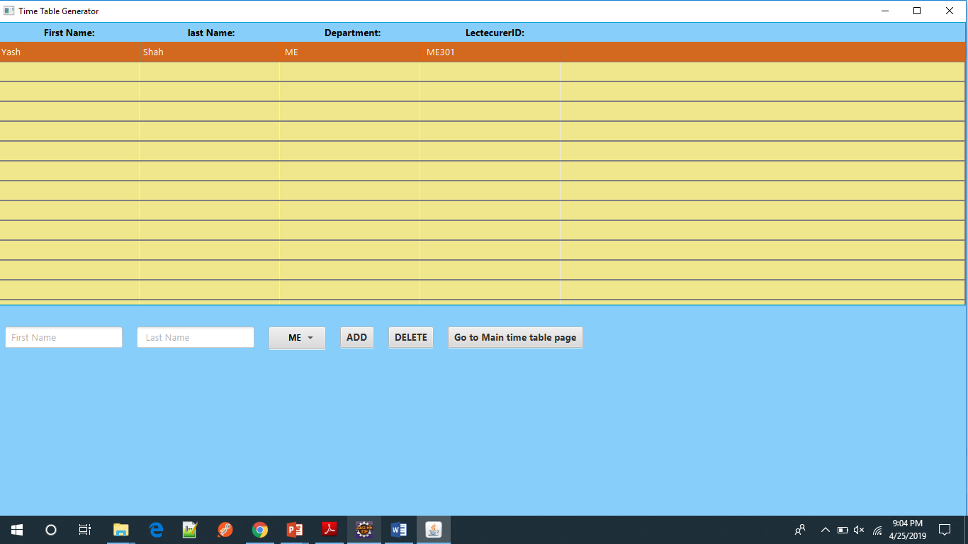*Fig 7.3 the table-view format for lecturer data entries*

**7.3 Course Allocation window**

* controller class-Pair

On clicking that “ADD” button on that lecturer window a new window will pop-up which is CourseAllocation window this window have many lists the first list is for selecting multiple course their list may be different depending upon the department choose by the user of lecturer window, the other list of the free slot by the lecturer in terms of the timing on each day of week.

when this “ADD COURSE” button is clicked the scene is been transfer to the lecturer window to add another lecturer.

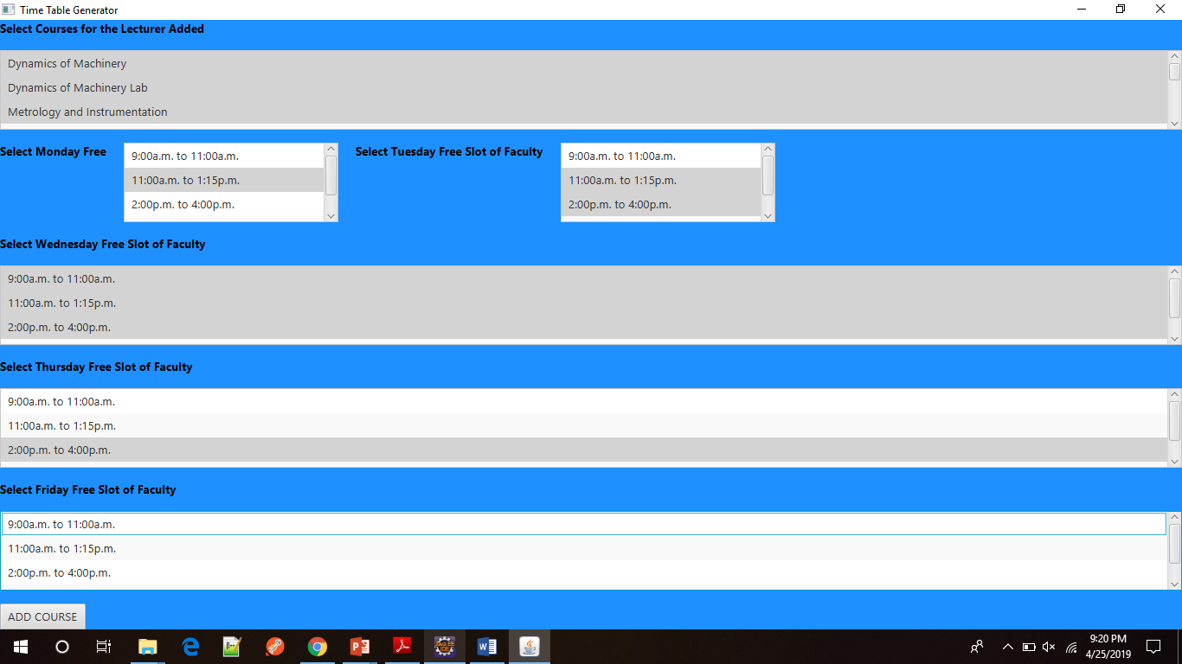

*Fig 7.4 Course Allocation*

**7.4 Final Time-Table Generated Window**

* Controller class – Allocation

This window is opened when the user click on the “ALLOCATION” button on the time-table class this window consist of 4 button they are generally of each department which consist of the time-table of each branch, the last button is of return to home which functionality is to return to time-table window(main page). when any of this button is been clicked a window will open consist of a time-table of particular branch which is been shown as below:

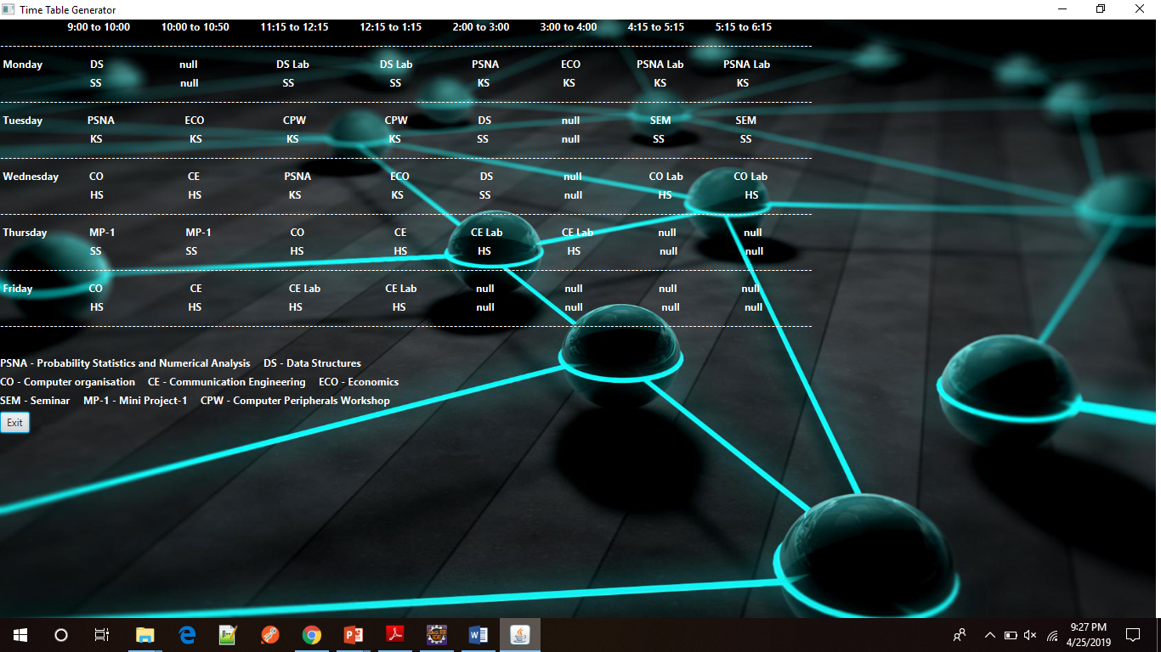

*Fig 7.5 Final Time Table Generated Window*

# 

# 8 Conclusion & Summary

# 8.1 Summary

In our project we have made time table generator where by taking basic information about every faculties in the institute like their name which courses do their teach and free time slot of all days in week we have generated timetable which will show the class timetable of four branches (i.e. CE,IT,ME,EC) showing course name and faculty assigned at each and every particular time from 9:00 a.m. to 6:00 p.m..

**8.2 Conclusion**

To generate timetable manually by human being will be very difficult given above all constraints and also it will take lot of time so according to need it would be easy to generate time table through system like this which is user friendly, easy to implement and will save lots of time.

# References

1. Cay S. Horstmann, Gary Cornell, *Core Java Vol I&II*, Addison Wesley
2. Herbert Schildt, *Java Complete Reference*, Tata McGraw-Hill Education
3. Pots & Stephen, *Unleashed Java 2 Platform*, SamsTechmedia

# Appendix A – List of Useful Websites

1) Javatpoint. "JavaFX Tutorial"

<https://www.javatpoint.com/javafx-tutorial>

2) The New Boston "JavaFX Java GUI Design Tutorials"

<https://www.youtube.com/playlist?list=PL6gx4Cwl9DGBzfXLWLSYVy8EbTdpGbUIG>

3) Tutorials Point. "JavaFX Tutorial."

<https://www.tutorialspoint.com/javafx/index.htm>